15.JPG
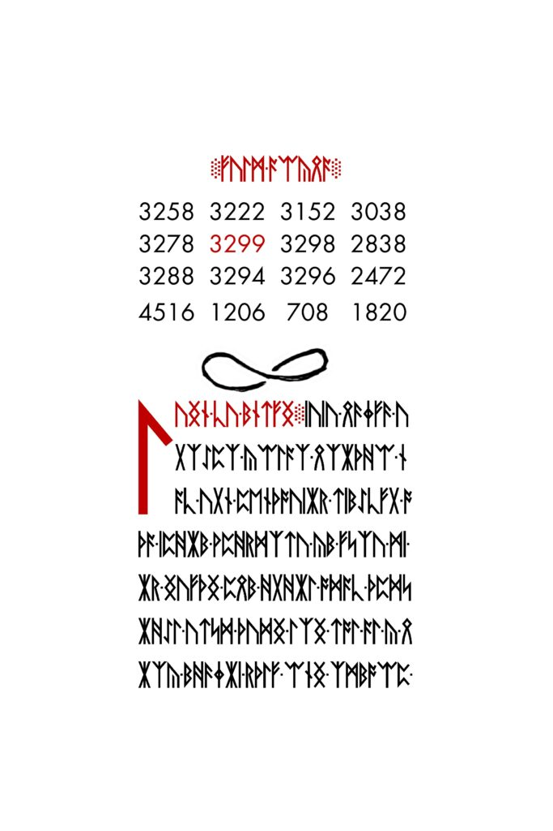

15.jpg
Runes ::: Delimiters ::: Art
~~~ Number Square ~~~
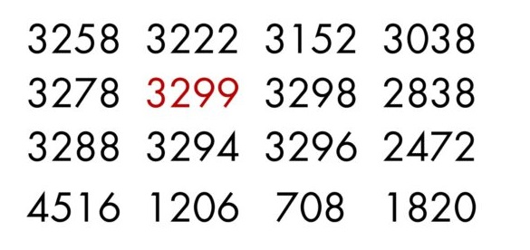15.jpg Number Square
The 4×4 Number Square featured on 15.jpg is mathematically translatable in various ways. Listed below are the known interpretations:
~~~~
1. Prime Order Recurrence Relation
2. Fibonacci Base
3. Zeckendorf’s Theorem
~~~~
Additional Reading
Mortlach
Fibonacci Base Analysis
Zeckendorf Analysis

15.JPG ART
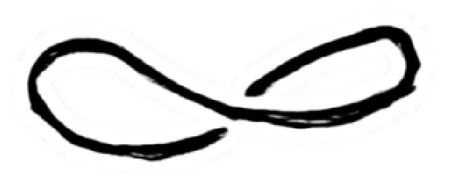15.jpg art
This symbol is found directly below the Number Square of 15.jpg. Its meaning is unknown.
Common Interpretations:
Infinity
Mobius

Notes:
Adjusting the contrast reveals a secondary figure.
*The image(s) featured on this page are scaled. For unmodified 3301 images and materials, download the Asset Pack.

